

**AN EFFICIENT BLOCKCHAIN BASED FRAMEWORK FOR FILE SHARING**

**A PROJECT REPORT**

***Submitted by***

**SHALINI D 820321205049**

**SIVAPRIYA H 820321205050**

**SNEHA S 820321205052**

**SRI NANDHINI R 820321205053**

***in partial fulfilment for the award of the degree***

***of***

**BACHELOR OF TECHNOLOGY**

**IN**

**INFORMATION TECHNOLOGY**

**A.V.C. COLLEGE OF ENGINEERING, MANNAMPANDAL,**

**MAYILADUTHURAI– 609 305**

**ANNA UNIVERSITY: CHENNAI -600 025**

**MAY 2025**

**ANNA UNIVERSITY: CHENNAI 600 025 BONAFIDE CERTIFICATE**

Certified that this project report “**AN EFFICIENT BLOCKCHAIN BASED FRAMEWORK FOR FILE SHARING”** the bonafide work of **SIVAPRIYA H (820321205050), SHALINI D (820321205049), SNEHA S (820321205052), SRI NANDHINI R (820321205053)** who carried out their project work under my supervision

|  |  |
| --- | --- |
| **SIGNATURE** | **SIGNATURE** |
| **Dr. K. KRISHNAKUMARI, Ph.D.,**  **HEAD & ASSOC. PROFESSOR**  Department of IT  A.V.C College of Engineering  Mayiladuthurai  Mannampandal-609 305 | **Mrs. V. EZHILARASI,**  **SUPERVISOR**  Assistant Professor  Department of IT  A.V.C College of Engineering  Mayiladuthurai  Mannampandal-609 305 |

# EXAMINED ON:

**INTERNAL EXAMINER EXTERNAL EXAMINER**

# ACKNOWLEDGEMENT

The success and final outcome of this project required a lot of guidance and assistance from many people, and we are extremely fortunate to have this all along the completion of my project work. Whatever we have done is only due to such guidance and assistance and we would not forget to thank them.

We extend our deep gratitude to our Administrator Justice **Mr. K. VENKATARAMAN** for the words of wisdom. We are sincerely obliged to our respected Principal **Dr. P. BALASUBRAMANIAN, M.E., Ph.D.,** who has always been a constant source of inspiration.

We express our respectful thanks to **Dr. K. KRISHNAKUMARI, M.E., Ph.D.,** the Professor and Head of our Department for her kind and mutual aid to complete our project.

At this juncture we feel deeply honoured in expressing our sincere thanks to our project guide **Mrs. V. EZHILARASI, M.E.,** and the project coordinator **Dr. K. KANIMOZHI, M.E., Ph.D.,** Associate Professor in our department, who took keen interest on our project work and guided us all along, till the completion of our project work by providing all the necessary information for developing a good system. We are also thankful all the review committee members for their valuable suggestions given in all reviews.

We are thankful to and fortunate enough to get constant encouragement, support and guidance from all **Teaching staff members** of our department which helped us in successfully completing our project work. Also, we would like to extend our sincere regards to all the **non-teaching staff members** of our department for their timely support.

Finally, we express our heartfelt gratitude to our **Parents and Friends** who had encouraged us in successful completion of our project and people who have willingly helped us out with their abilities.

# ABSTRACT

The widespread use of online social networks has resulted in a surge in photo sharing, but the vulnerability of photo privacy becomes apparent when these images are disseminated across multiple platforms. Current solutions often fall short in delivering efficient social network services without compromising user privacy. Introducing Photo Chain, a revolutionary blockchain-based framework designed to facilitate secure photo sharing across social networks. This framework incorporates advanced features, including dissemination control, face masking, photo integrity verification, access control, and dynamic privacy policy generation. Leveraging smart contracts, Photo Chain ensures a consistent consensus on dissemination control, while robust mechanisms for photo ownership identification are integrated to thwart illegal reprinting. A fully functional prototype has been implemented and rigorously tested, substantiating the framework's prowess in delivering security, efficacy, and efficiency for photo sharing across social networks.

**Keywords**: Photo privacy, Blockchain, Dissemination control, Smart contracts, Access control

# TABLE OF CONTENTS

|  |  |  |
| --- | --- | --- |
| **CHAPTER**  **NO** | **TITLE** | **PAGE NO** |
|  | **ABSTRACT** | iv |
|  | **LIST OF FIGURES** | Vii |
|  | **LIST OF TABLES** | Viii |
|  | **LIST OF ABBREVIATIONS** | ix |
| **1** | **INTRODUCTION** | 1 |
|  | 1.1 Social media | 1 |
|  | 1.2 Problem Identification | 2 |
|  | 1.3 Traditional Approaches | 3 |
|  | 1.4 Importance of securing photos | 3 |
| **2** | **LITERATURE SURVEY** | 4 |
| **3** | **SYSTEM SPECIFICATION** | 11 |
|  | 3.1 Hardware Requirements | 11 |
|  | 3.2 Software Requirements | 11 |
| **4** | **ANALYSIS OF PROJECT** | 12 |
|  | 4.1 Use Case analysis | 12 |
|  | 4.2 Activity Diagram | 13 |
| **5** | **SYSTEM DESIGN** | 16 |
|  | 5.1 Proposed System | 16 |
|  | 5.2 Photochain based secure photo sharing System Architecture | 17 |
| **CHAPTER**  **NO** | **TITLE** | **PAGE NO** |
|  | 5.3 Modules of the Project | 20 |
|  | 5.3.1 SN Web App  5.3.2 Share/Post/Comment/Chat  5.3.3 Photo Privacy  5.3.4 Photo Blurring  5.3.5 Privacy Violation  5.3.6 Photochain Integration  5.3.7 Photo Verification Modules | 20  20  21  22  23  23  24 |
| 6 | **IMPLEMENTATION** | 26 |
| 7 | **RESULTS AND DISCUSSION**  7.1 Output  7.2 Model Accuracy  7.3 Comparison with other models | 30  30  36  37 |
| 8 | **CONCLUSION AND FUTURE**  **ENHANCEMENT**  8.1 Conclusion  8.2 Future Enhancement | 38  38  39 |
|  | **APPENDICES** | 40 |
|  | **APPENDIX - 1 Coding** | 40 |
|  | **APPENDIX - 2 Publications in Conferences** | 46 |
|  | **References** | 50 |

**LIST OF FIGURES**

|  |  |  |
| --- | --- | --- |
| **Figure No** | **Figure Name** | **Page No** |
| 1.1 | Social media | 1 |
| 4.1 | Use case analysis for SN web app | 12 |
| 4.2 | Activity diagram | 14 |
| 5.2.1 | System Architecture | 17 |
| 5.2.2 | Flow Diagram | 19 |
| 5.3.3 | Photo blurring | 22 |
| 7.1.1 | Social Media Login Page | 30 |
| 7.1.2 | Choosing Image | 30 |
| 7.1.3 | User profile | 31 |
| 7.1.4 | Post Image | 31 |
| 7.1.5 | New Friend List | 32 |
| 7.1.6 | Friend List | 32 |
| 7.1.7 | Friend Request List | 33 |
| 7.1.8 | Posting Images in Blur Mode | 33 |
| 7.1.9 | Posting Images in Blur Mode | 34 |
| 7.1.10 | Social Media Register Page | 34 |

7.1.11 Request photo 35

7.1.12 Alert Notification 35

7.2.1 Model Accuracy 36

**LIST OF TABLES**

|  |  |  |
| --- | --- | --- |
| **Table No** | **Table Name** | **Page No** |
| Table 7.3.1 | Comparison with other models | 37 |

**LIST OF ABBREVIATIONS**

|  |  |
| --- | --- |
| **ABBREVIATION** | **EXPANSION** |
| AUC | Area Under Curve |
| DL | Deep Learning |
| DWT | Discrete Wavelet Transform |
| GUI | Graphical User Interface |
| KNN | K-Nearest Neighbours |
| LTS | Long Term Support |
| ReLU | Rectified Linear Unit |
| ROC | Receiver operating system |
| SNS | Social Network Site |
| SSN | Social Security Number |
| SNS | Social Network Site |
| VGG19 | Visual Geometry Group 19 |

**CHAPTER 1**

**INTRODUCTION**

# 1.1 Social media

With the huge popularity of sharing and the vast usage of social networking sites users unknowingly reveal certain kinds of personal information. Social-networking users may or may not have the idea of getting their personal information will be leaked or could pro the malicious attackers and may perpetrate significant privacy breaches. The rest decade of 21st century has seen the extreme popularization of Internet and the growth of web services which facilitate participatory information sharing and collaboration.



**Fig.1.1Social Media**

Social Networking Sites (SNSs) have become a boundless communication media to keep in touch beyond boundaries. SNSs are a part of human culture than just a web application. Use of SNSs has out spaced in almost every field as news agencies, big and small companies, governments, and famous personalities etc. to interact with each other. With the adoration of sharing, Facebook has stood out as the most renown SNSs in the world were people hangout for hours. With the extravagancy of technology and services sharing of news, photos, personal taste and information with friends and family has led to an ease. But along with this user privacy should also be taken into consideration. An issue related to privacy with Facebook users has been constantly appearing on international press either because of the companies privacy policy or because of users unaware-ness of content sharing consequences. As research says the simple disclosure of date and place of birth of a pro le in Facebook can be used to predict the Social Security Number (SSN) of a citizen in the U.S. Many a times just by simply publishing their friends list, users might be revealing a large amount of information. For example, through the use of prediction algorithms it is possible to infer private information that was previously undisclosed. Sometimes sensitive information even comes embedded in the photo as metadata and may identify people on the photo by accompanying more information that could be exploited, like captions, comments and photo tags; marked regions. Even if the individuals in a photo are not explicitly identified by photo tags, the combination of publicly available information and face recognition software can be used to infer someone’s identity. These kinds of problems are defined as collateral damage: users unintentionally put their own privacy or their friend’s privacy at risk when performing events on SNSs such as Facebook. The main focus is to let each user only deal with his/her private photo set as the local train data which can be used by the users to learn out the local training result. Once the local training results are achieved then it can be exchanged among various users to form a global knowledge

# 1.2 PROBLEM IDENTIFICATION

The rapid growth of online social networks has led to an exponential increase in photo sharing, inadvertently raising serious concerns about photo privacy and unauthorized dissemination. Existing systems struggle to balance efficient photo sharing with robust privacy protection, often exposing users to risks such as identity theft, misuse of personal images, and lack of control over how and where their photos are shared. Moreover, conventional privacy safeguards lack transparency, traceability, and user-centric control mechanisms. This calls for an innovative solution that not only secures photo sharing but also empowers users with control over their content. The problem, therefore, lies in developing a secure, scalable, and privacy-preserving framework that ensures ownership verification, dissemination control, and access regulation without sacrificing usability—gaps that the proposed Photo Chain system aims to address through blockchain technology and smart contracts.

* 1. **Traditional Approaches**

Traditional approaches to securing photo sharing on social networks primarily involve centralized access control systems, manual user permissions, and basic encryption techniques. These methods typically rely on the trustworthiness of social media platforms to enforce privacy settings and manage the dissemination of user-generated content. However, such centralized systems often lack transparency, are prone to breaches, and offer limited control once content is distributed. In many cases, users are unaware of how or where their photos are being used or shared, especially when reposted across multiple platforms. Additionally, current privacy configurations are often static, offering minimal flexibility or adaptability to changing user preferences. These limitations expose users to significant risks, including unauthorized sharing, misuse of facial images, and the loss of ownership rights over their content.

* 1. **Importance of Securing Photos**

Protecting personal photos on social media is essential in today’s digital age, where visual content plays a major role in communication and self-representation. Privacy breaches involving personal images can result in identity theft, reputational damage, and emotional distress. As online interactions increase, the integrity and security of photo sharing mechanisms become critical to user trust and platform credibility. There is a growing demand for systems that can provide dynamic and reliable control over shared media without compromising user experience. The integration of technologies that ensure authenticity, ownership, and secure dissemination of digital images is not just a technical need but a societal imperative to preserve privacy, uphold consent, and promote responsible digital interactions.

# LITERATUR SURVEY

# [1] Facial Detection and Anonymization for Privacy Protection from Social Networking Sites(SNS)

A social networking site (SNS) is an incredible information exchange platform that helps advance and shares a lot of useful information regarding items, news, training, travel, medical care, etc. However, there are a lot of risks involved with protecting a person's safety and security. Posts of photos online can be shared, labelled, and reposted again without the permission of the individuals pictured. Using facial recognition, we propose a framework for identifying each person and examining the web-based account connections between people. Replicated, labelled, or replicated posts will be checked, regardless of whether they're by a known or unknown individual. Whenever a person is obscure, the images are convolved through a low-pass filter in order to eliminate clamour and edges that obstruct the image. The proposed solution used deep-learning-based VGG19 engineering to characterize pictures, Haar overflow viola jones calculations for location, and PC vision-based obscuring methods to remove objects from the picture. Thus, a region under the ROC curve (AUC) precision of 88% was achieved. There was a 91.53% accuracy achieved by using the proposed model, and we also assessed the model using Precision, Accuracy, Review, and F1-Score matrices, which yielded an accuracy of 70.83%, 82%, 71%, and 0.68% respectively.

# [3] Hidden Privacy Risks in Sharing Pictures on social media

# Shared pictures, videos and more constitute as shared media in today’s world of social networks. Each piece of media shared has hidden privacy violations stored in their metadata. Over the past two decades, social media sites, and shared media on them, have grown exponentially. People are sharing more data, and with more people, such unknowing users easily become the victims of numerous types of privacy attacks. By creating a GUI based metadata reader and editor, much of this security risk can be alleviated for common users. By bringing the capability to view and change metadata to different platforms, the true risk, hidden in all shared media, can be brought outright and mitigated. Much of the important data that can be exposed deals with geotags for locations, as well as camera identification numbers, and time stamps. In this work, we discuss the importance of having control of this type of information and share a model application that can be used to help resolve privacy breaches of this type.

# [5] Privacy-Photo Sharing in Social Media Platform

The social communication platform, sharing snapshots, videos, and much more information has become a prominent way of retaining connections with multiple users. Despite the sensitive data the photo holds, it will be an effortless way for the evil-minded user to steal the data of those who appear in the picture**.** To aim of this project privacy-protected mechanism based on the level of assurance the interconnected client gives to the person who uploads the picture. The thought process of this mechanism is while uploading an image of a co-owned photo, and a request is sent to the related user based on the reply the related user gives; the photo is displayed to the followers of the uploader. With the help of this privacy, the related user will not be compromising. This paper brings out an adaptive concealment policy indicator mechanism stated in that provides a policy to the client while sharing the picture with multiple clients. This policy helps the client decide whether to share an image based on their trust in the recipient. This paper is help to the problem of Sharing sensitive information such as images and videos may help connect with others. On the other side, those data may be misused and threaten the lives of others. The privacy-protected photo sharing mechanism helps users bother about their privacy the most to connect with others and safeguard sensitive information. finally, it displays a hidden image where the particular person’s face is blurred. This proposed mechanism proves to be an effective method in controlling the loss of privacy.

# [13] No Filters: A Deep Dive into Photo Sharing Apps on Android and iOS

Photo and video-sharing applications have gained popularity among all age groups. These applications allow users to create, share, and interact with multimedia content. Unfortunately, some of these applications have been used to harass, exploit, cyberbully, solicit/groom minors, or track any users' physical location. Consequently, they have become a significant source of evidence in digital investigations. In this paper, we conduct a comprehensive forensic investigation of two relatively new and highly popular photo-sharing applications on both Android and iOS devices. Our goals are to (1) provide a forensic roadmap for forensic investigators who may encounter these or similar applications during a case, (2) highlight the privacy concerns that these applications' users should be made aware of, and (3) discuss the implications of not using multiple tools for artifact validation. Our findings illustrate the lack of privacy and security measures in place for these applications' users, which are location-specific artifacts that can be easily recovered along with plaintext chat messages. Additionally, our findings highlight the inability of commercial tools to uncover pertinent evidence and thus reinforce the need for investigators to use multiple tools during a forensic investigation.

# [16] Predicting Gender from Human or Non-human Social Media Profile Photos by using Transfer Learning

Social media profile photos can demonstrate a variety of information about a person, including her personality, behaviour, preference, individuality, and gender. Prediction of gender from social media photos has a number of real-life applications such as gender marketing and identification of camouflaged profile photos. Numerous techniques can be applied for determining gender from a user’s profile photos. In this study, we predict a user’s gender from her social media profile photos (i.e., Facebook, Twitter, and Instagram) by using multiple transfer learning models. While conventional methods are straightforward and can only determine gender based on human faces, we propose a novel model that determines gender based on both human faces and non-human pictures (i.e., a flower, animal, cartoon, doll, etc.). The model predicts the gender of a user based on the pattern of sharing profile photos with an outstanding accuracy of 95.75%.

# [20] Security Concerns during Photo Sharing in Social Network Platforms

Security concern mechanism is outlined to assist the distributor to form an educated choice. Or maybe, the distributor predicts the misfortune of security for any connected client as it were since a single client offers the symbol. To proposed believe based privacy-preserving photo sharing in online social systems. This strategy chooses the picture's fashion and compared to numerical points of interest. Pictures give the onlooker with a number of expand records, now and then unfavourable to the protection of the individual. A Privacy Concerns for Photo Sharing in Online Social Networks is proposed to help the publisher to make a proper decision. Different from our previous work the publisher does not communicate with other related users before he posts the photo. Instead, the publisher predicts the privacy loss to each related user in case that the photo is shared with a certain user. This mechanism explores the trust between users to measure the privacy loss. A system for security employments in specific values to characterize an anonymized picture. With the assistance of the benefit supplier, the picture that a client wishes to compare is held quickly. The benefit merchant calculates the extent of misfortune of security by sharing the picture as empowered by the relationship of certainty between the users. Instead, by utilizing the author, the benefit merchant makes a choice with the help of comparing the misfortune of security with an edge such that an unbiased must be evacuated from the picture

# [19] Detection of Morphed Face Images Using Discriminative Wavelet Sub-bands

Morphed images have exposed face recognition systems’ susceptibility to false acceptance, resulting in dire consequences, especially for national security applications. To detect morphing attacks, we propose a method which is based on a discriminative 2D Discrete Wavelet Transform (2D-DWT). To aim of this project is propose a method which is based on a discriminative 2D Discrete Wavelet Transform (2DDWT). A discriminative wavelet sub-band can highlight inconsistencies between a real and a morphed image. We observe that there is a salient discrepancy between the entropy of a given sub band in a bona fide image, and the same sub-band’s entropy in a morphed sample. A morphed image is generated using genuine face images from two different individuals. Because the resulting morphed image inherits characteristics of both subjects, it can be verified against both real subjects. Morphed images are generated using two approaches. In this paper, we proposed a framework to detect morphed face images using undecimated 2D-DWT. To select the optimal and informative bands, we found the distribution of the entropy for all the 48 wavelet sub-bands considering both the bona fide, and morphed images. The KL-divergence between the given distributions, integrated in a data-driven approach, led us to select the 22 most discriminative sub-bands.

# [9] Photo Sharing and Storing Over Online Social Networks Based Trust & Privacy

While sharing these data like pictures may consists of other user’s information, publisher may tag to the other users who are present in the data or tag to the users who relative that post, this process is called Tagging. This tagging may damage the tagged user’s privacy that may express data of user’s location, presence or sexual content etc. It is a privacy loophole for the user’s who are taking space in the photo with publisher of the picture. Privacy preserving in social networks in sharing data is current hot research topic in Social Networking. To proposing a system called Privacy Preserving Framework for sharing data in social networks. Our System will identify the co-owner faces from the sharing data and tag to the co-owner’s accounts for taking permission from the co-owners. For this we are using Machine Learning methods of K- Neighbours Classifier algorithm for detection of users in shared data. In this study of the face matching concept, we are using the K-Nearest Neighbour’s algorithm. In the KNN algorithms there are multiple sub methods are there, in our project we are using Ball-Tree algorithm. Ball-Tree algorithm also called as Binary Tree algorithm. In this algorithm each and every node creates a D-dimensional hypersphere, containing a subset of the points to be searched. After constructing the B–Tree we save the prediction parameters in clf file. This paper is to help for this we are using Machine Learning methods of K-Neighbours Classifier algorithm for detection of users in shared data. Based on these situations we are proposing a system called Privacy Preserving Framework for sharing data in social networks. Our architecture will match the co-owner faces from the sharing data and tag to the coowner’s accounts for taking permission from the co-owners.

# [5] Go-Sharing: A Blockchain-Based Privacy-Preserving Framework for Cross-Social Network Photo Sharing

The evolution of social media has led to a trend of posting daily photos on online Social Network Platforms (SNPs). The privacy of online photos is often protected carefully by security mechanisms. However, these mechanisms will lose effectiveness when someone spreads the photos to other platforms. In this article, we propose Go-sharing, a blockchain-based privacy-preserving framework that provides powerful dissemination control for cross-SNP photo sharing. In contrast to security mechanisms running separately in centralized servers that do not trust each other, our framework achieves consistent consensus on photo dissemination control through carefully designed smart contract-based protocols. We use these protocols to create platform-free dissemination trees for every image, providing users with complete sharing control and privacy protection. Considering the possible privacy conflicts between owners and subsequent re-posters in cross-SNP sharing, we design a dynamic privacy policy generation algorithm that maximizes the flexibility of re-posters without violating formers’ privacy. Moreover, Go-sharing also provides robust photo ownership identification mechanisms to avoid illegal reprinting. It introduces a random noise black box in a two-stage separable deep learning process to improve robustness against unpredictable manipulations. Through extensive real-world simulations, the results demonstrate the capability and effectiveness of the framework across a number of performance metrics.

# [10] A blockchain-based Privacy-Preserving Framework for Cross-Social Network Photo Sharing

Posting daily photos on online Social Network Platforms (SNPs) has become a trend. As a kind of sensitive privacy, social photos are often protected carefully by SNPs with various security mechanisms. However, these mechanisms can not stop users from losing control of their photos when someone forwards these photos to another platform. In this paper, we propose a blockchain-based privacy-preserving framework that provides powerful dissemination control for online photos in cross-social network sharing. In contrast to existing security mechanisms that run separately in centralized servers, which hardly create trust between each other, our framework achieves consistent consensus on photo dissemination control across independent and disparate platforms through carefully designed smart contract-based protocols. Considering the numerous participants in real photo dissemination, we present a novel concept of multi-owner dissemination tree to be compatible with all privacy preferences of subsequent forwarders in cross-SNPs photo sharing. This paper describes a prototype implementation on Hyperledger Fabric 2.0 with demonstrating its preliminary performance by a real-world dataset and identifies the remaining challenges

# CHAPTER 3

# SYSTEM SPECIFICATION

* 1. **HARDWARE REQUIREMENTS**
* Processors: Intel® Core™ i5 processor 4300M at 2.60 GHz or 2.59 GHz (1 socket, 2 cores, 2 threads per core), 8 GB of DRAM
* Disk space: 320 GB
* Operating systems: Windows® 10, macOS*, and Linux*

# SOFTWARE REQUIREMENTS

* Server Side : Python 3.7.4(64-bit) or (32-bit)
* Client Side : HTML, CSS, Bootstrap
* IDE : Flask 1.1.1

Back end : MySQL 5.

* Server : WampServer 2i
* OS : Windows 10 64 –bit or Ubuntu 18.04 LTS “Bionic Beaver”

# CHAPTER 4

# ANALYSIS OF THE PROJECT

* 1. **USE-CASE ANALYSIS**

The use case diagram shows the functional workflow of a social networking web application built on top of blockchain. The main actor in the system is the SN User (Social Network User), which uses different functionalities offered by the platform. They are shown as use cases and encompass core social networking features like registration, account creation, chatting, sharing, and commenting, and request and response handling. Aside from usual user activities, the diagram focuses on sophisticated functions made possible through blockchain technology, such as block confirmation, access control policies, enforcement of privacy policy, generation of keys, encryption/decryption of photos, and blurring of photos to protect privacy.



**Fig.4.1.1 Use Case Analysis for SN Web App**

Other key functionalities like blocking users and data analysis are also integrated into the system, highlighting its strong capacity for safe user management and smart data-driven intelligence. With the inclusion of a block user feature, the system can enforce community rules and provide users with protection against unwanted or malicious interactions, thus creating a safer social networking environment. In the same way, the data analysis module assists in user behavior tracking, pattern identification, and the creation of useful statistics that can improve decision-making and platform performance optimization.

While Blockchain is not depicted as a standard user or external user, it is represented as a central technological element in the architecture. Its function is more than mere support functions—it is a base layer that protects data storage, enforces access control policies, manages encryption and decryption, and facilitates privacy-preserving operations like photo blurring and secure key generation. With this integration, the application not only provides ordinary social networking features like registration, communication, and content sharing but also uses blockchain to provide data confidentiality, immutability, traceability, and user anonymity.

* 1. **ACTIVITY DIAGRAM**

The activity diagram depicts the process flow of a blockchain-based social networking web application, with three principal actors: SN User, Blockchain, and Social Network. It starts with the SN user triggering the process by login to the system. Following login, the user then goes ahead to register a social network account and is subsequently able to perform basic platform actions such as chatting, posting content, and commenting. Also, the user can approve or reject connection requests, which form a part of social experience.



**Fig.4.2.1 Activity Diagram for User Authentication**

On the blockchain front, secure registration and login authentication is managed by the system for authenticating user credentials and activities. After authenticating, the blockchain communicates with a secure database and enforces access control rules to safeguard user data. This is done to ensure that user interactions are securely stored and processed, and data integrity as well as privacy is ensured through decentralized means. An interaction from user actions such as chat or requests to the database layer of the blockchain is also present, which shows that user data is passed through blockchain validation.

The social network module operates in conjunction with the blockchain and encompasses further features like data analysis in order to track and analyse user activity or content trends. Whenever a user shares an image, it goes through photo blurring for privacy protection prior to sharing. In case of need, inappropriate users or content can be dealt with using the block user feature. The diagram progresses from a point of departure (initial node) to a destination (termination node), explicitly showing how user actions flow through secure and controlled steps through the system.

In general, this activity diagram gives a detailed overview of how blockchain technology elevates the security, privacy, and control processes of a social networking site but still accommodates normal user interactions.

# CHAPTER 5

# SYSTEM DESIGN

# 5.1.PROPOSED SYSTEM

Photo Chain, a blockchain-based secure photo sharing framework that provides powerful dissemination control for cross-social network photo sharing, Combined with blockchain, Gaussian Blur for Face Masking, PreHash Algorithm for Photo integrity verification and Access Control, Mechanism can achieve secure data sharing, data retrieving, and data accessing with fairness and without worrying about potential damage to user’s interest.Blockchain Network: The blockchain network is the underlying technology that powers the photochain platform. It is a decentralized network of computers that work together to maintain a secure and transparent ledger of all the transactions on the platform. The blockchain network used by PhotoChain is based on Ethereum, a popular blockchain platform that supports the development of smart contracts. Client Application: The client application is the user-facing part of the photochain platform.It is a mobile or web-based application that enables users to upload, view and share their photos securely. The client application is designed to be user-friendly with an intuitive interface that allows users to easily navigate and use the platform. Gaussian Blur Algorithm: It is a common image processing technique that applies a Gaussian filter to an image, smoothing out the details and reducing the noise, resulting in a blurred image. It works by convolving the image with a Gaussian function to create a blurred version of the original image. PreHash algorithm: It is a method for verifying photo integrity and enabling access control. It involves generating a hash code from the photo’s metadata and comparing it to a precomputed hash code to determine if the photo has been tampered with or if the user has the appropriate access privileges.

# SYSTEM ARCHITECTURE

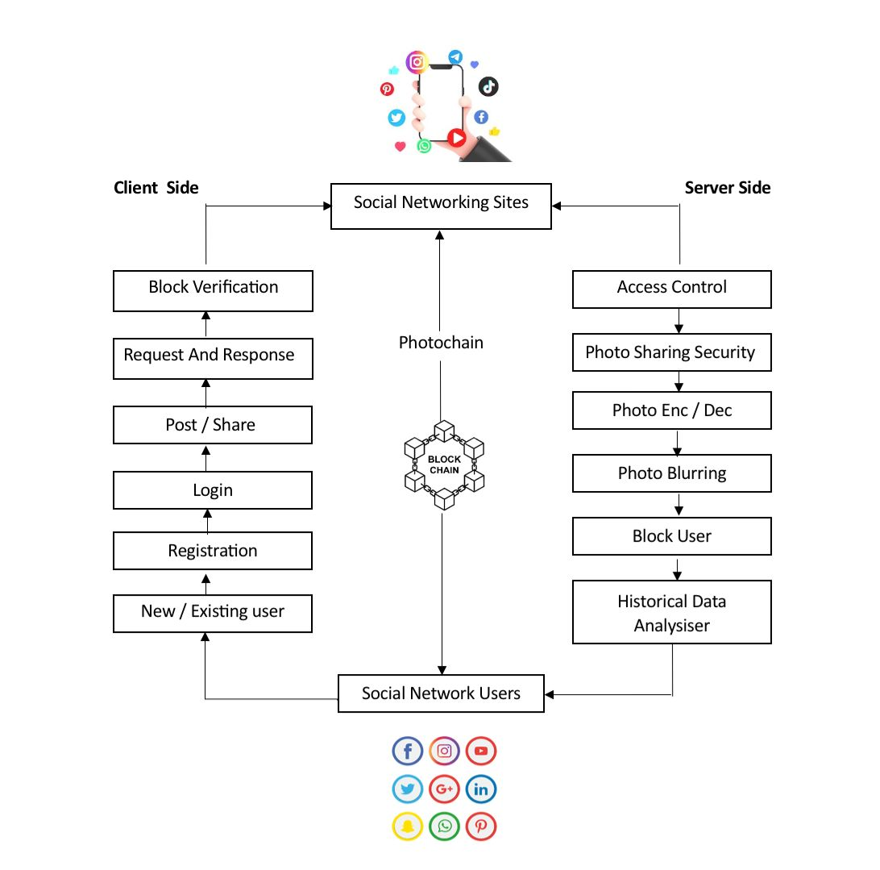

**Fig 5.2.1 PHOTOCHAIN BASED SECURE PHOTO SHARING SYSTEM ARCHITECTURE**

As shown in fig.2.1 The PhotoChain system, a blockchain-powered solution developed to ensure secure, private, and controlled photo sharing across social networking platforms. At the heart of this architecture lies the blockchain, which acts as the decentralized foundation for all transactions and interactions involving user photos. The process begins with users—either new or existing—who first register or log in to the system. Once authenticated, users can initiate photo sharing actions by uploading or posting images. These actions are passed through a request and response mechanism where blockchain nodes perform block verification to ensure the integrity, authenticity, and compliance of the content with pre-defined privacy rules. Once verified, the photo sharing request is securely forwarded to the respective social networking sites such as Facebook, Twitter, Instagram, or WhatsApp. On the right side of the diagram, a suite of privacy and security features is integrated to enhance user control over their content. These include access control mechanisms that define who can view the photos, encryption and decryption modules to ensure end-to-end data security, and photo blurring functionalities that automatically mask faces or sensitive areas in images to protect identity. Additionally, the system allows users to block specific individuals from accessing their content and leverages a historical data analyser to track past interactions and detect unusual or unauthorized sharing behaviour. All these modules work cohesively under the governance of smart contracts, which automatically enforce user-defined policies and ensure consistent dissemination control. This robust interaction between the blockchain core and the social media layer ensures that photos are not only shared efficiently but also with strong guarantees of privacy, ownership, and security. Ultimately, social network users receive shared images through a secure, transparent, and user-centric system, reducing risks of unauthorized distribution or misuse. The diagram comprehensively outlines how Photo Chain bridges the gap between privacy concerns and the widespread nature of photo sharing in modern digital environments.

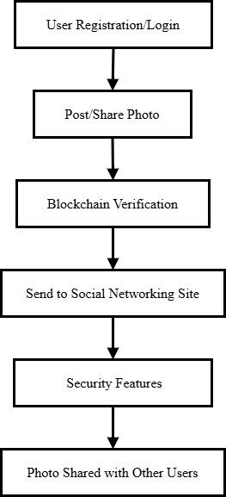

# Fig 5.2.2 Flow Diagram for Secure Photo Sharing

**5.3 MODULES OF THE PROJECT**

1. SN Web App
2. Share/Post/Comment/Chat
3. Photo Privacy
4. Privacy Violation
5. Photo Verification Module

**5.3.1 SN Web App**

Long range informal communication administration refers to an internet-based platform where individuals can create social networks or personal relationships with individuals sharing the same interest, hobby, background, or real-life connections. Such a platform functions as a virtual community where users interact, exchange content, and remain connected.

On this site, individuals have the option to link with acquaintances, form new relationships, or even widen their professional network. If an individual is keen on photography, traveling, music, career growth, or just socializing, this site provides them with the arena in which to vent and interact with similar-minded individuals.

Another salient aspect of the site is the uploading and sharing of images. The users who desire to view the website and post their photos must register through providing their individual information. Registration assists in building the profile of every user, including fundamental information such as their name, email, interests, and a profile picture.

**5.3.2 Share/Post/Comment/Chat**

In which, clients can give companion demands, acknowledge companion demands, and key solicitation to uncover private pictures in the site. Sharing Photograph Client can share a photograph just to companions on list. As per the proposed plot, this companion rundown ought to be crossing point of proprietor's protection strategy and co- proprietors' openness policies.Friend Solicitation A sign in/out button could be utilized for sign in/out with the social site. Subsequent to signing in, a hello message and the profile picture will be shown. This model works in three modes: an arrangement mode, a resting mode and a functioning mode. To answer a companion demand, you have two options. One is to click one of the two buttons to one side of your expected companion's name.

Image and Message Encoding

Our encoder network comprises of down sampling layers, leftover layers, and up sampling layers. The construction of encoder network. In the resnet, it incorporates many skip associations with combine the shallow elements and profound highlights in the different convolution stages. The shallow component incorporates a great deal of low-level proficient data about the blueprint and shade of picture, which is extremely helpful for the age of steganographic pictures. Crafted by built the encoder network like the design of U-Net, and its outcomes have demonstrated that the skip association is powerful to lessen the mutilation of steganographic pictures and work on the visual nature of steganographic pictures.

**5.3.3 Photo Privacy**

In this cycle, security data of the photograph is safeguarded by utilizing the chose insurance device and a mystery key (or a bunch of keys) set by the shipper. Aside from giving a legitimate security level and a productive execution, one important test is to appropriately deal with all the encryption keys utilized in the framework. We propose a concentrated methodology where all keys are put away in the believed Key Server. The works of built the encoder network like the design of U-Net, and its outcomes have demonstrated that the skip association is compelling to decrease the bending of steganographic pictures and work on the visual nature of steganographic images. Gaussian obscure (otherwise called Gaussian smoothing) is the consequence of obscuring a picture by a Gaussian capability (named after mathematician and researcher Carl Friedrich Gauss).

Image and Message Decoding

The decoder network made out of a 6-layer full convolutional network removes the mystery variety pictures (S') from steganographic pictures (C'). The decoder organization and the encoder network in the past segment comprise the generator of the proposed model HIGAN. The engineering of the decoder network has been demonstrated in past work to actually recreate single-channel grayscale secret pictures and three-channel variety secret pictures. All 3×3 convolutional layers with step 1 and cushioning 1 are trailed by bunch standardization (BN) activity and ReLU actuation capability. Yet, sigmoid enactment capability was utilized after the last convolutional layers. At long last, the decoder network uncovers the mystery picture’s

**5.3.4 Photo Blurring**

Gaussian haze (otherwise called Gaussian smoothing) is the consequence of obscuring a picture by a Gaussian capability (named after mathematician and researcher Carl Friedrich Gauss). It is a generally involved impact in illustrations programming, commonly to lessen picture commotion and decrease detail. The enhanced visualization of this obscuring strategy is a smooth haze looking like that of review the picture through a clear screen, particularly unique in relation to the bokeh impact created by an out-of-state focal point or the shadow of an item under regular brightening. Gaussian smoothing is likewise utilized as a pre-handling stage in PC vision calculations to upgrade picture structures at various scales — see scale space portrayal and scale space execution.

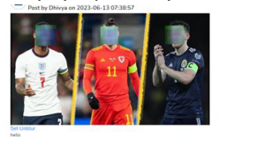

**Fig.5.3.4 Photo Blurring**

**5.3.5 Privacy Violation**

The Check Policy Status mechanism is also of utmost importance in upholding privacy and sharing based on consent on the site. Both photo owners and co-owners of each user can set an individual privacy policy and an exposure policy, which together decide who can view or engage with shared items. If a user tries to upload an image that engages or impacts other users (e.g., group images or tagged individuals), the system cross-checks in advance whether the request to share complies with the privacy policies of everyone involved. That is, the system does an intersection check of policies so that both the uploader's privacy settings and the co-owner's visibility preferences are met.

If policies are matched successfully, then the system continues by issuing a notice to the co-owner, in which they are notified of the request for photo upload. But even after this, the last word lies in the hands of the original owner of the photo. The photo will only be uploaded to the site after receiving an explicit permission to publish. If the owner rejects the upload or fails to reply, the image stays in blocked mode and is never published on the website. This method ensures private or sensitive images are not inadvertently or unwillingly released, hence upholding user confidence and authority over their digital media. This approach also fosters collective consent, ensuring that all participating users get to have their voices heard on what is being shared, thereby leading to a more respectful and secure sharing culture.

**5.3.6 Photo Chain Integration**

Photo Chain is a new decentralized social networking (SN) data sharing and storage platform that leverages the security, transparency, and decentralization of the blockchain technology to radically change how user data is managed and exchanged. Centralized architectures are traditionally used in social media platforms where the service providers store and control user data such as personal data, photos, and interactions. This model poses serious issues regarding privacy, misuse of data, unauthorized access, and user control. PhotoChain resolves these issues by separating user data from the app layer, thus making sure that the data is under the explicit control of the user and not the platform. All the content posted on PhotoChain—images, captions, and metadata—are stored securely in a distributed blockchain network, which ensures data immutability (permanent, unchangeable once written), transparency, and censorship resistance. Users can utilize smart contracts to specify and implement their own access control policies, including exactly who may view, comment on, or share their content. These smart contracts enforce user-specified policies automatically without requiring a centralized authority. Moreover, as each transaction and data access event is recorded on the blockchain, users obtain complete auditability and accountability and are able to monitor how their content is being used. PhotoChain not only enables people by taking back complete data ownership but also presents a new model for trustless peer-to-peer communication and sharing of content. It is advocate for digital sovereignty, better security from data breaches, and a new standard for ethical and privacy-oriented social networking in the internet era.

* + 1. **Photo Verification Module**

The Photo Verification Module is programmed to protect the ownership and authenticity of the photos posted on the social networking site at the same time with tight control by the users over privacy. Upon posting a photo, the module authenticates it as an original by comparing it against stored information on the decentralized blockchain network that prevents the data from being tampered with or edited. This process maintains authenticity and prevents forgery and unauthorized changes, establishing trust among the user base. Apart from verification, the module also has email alerts and notification messages to remind users of important activity on their photos. For instance, when a photo needs to be verified or approved before sharing, the owner as well as co-owners are notified immediately via email and in-app notification. They also notify users of any attempts to look at private images, modifications in access permissions, or when their content has successfully been shared or blocked. Through offering instantaneous communication and openness, the module keeps users informed about what is happening with their photos and makes them completely in charge of their own content. This union of secure verification, privacy settings controlled by the user, and proactive alerts makes a safe and user-friendly atmosphere for picture sharing on the platform.

# 

# 

# 

# CHAPTER 6

# IMPLEMENTATION

* 1. **Model Building**

This Flask-powered Python code manages user login, home page rendering, and friend request listing for a social network app. The /login endpoint validates users by checking credentials against a MySQL database and saves user information in session variables. Users are redirected to the /home endpoint upon successful login, which renders their posts and posts of approved friends. The /list path fetches the pending friend requests of the current user through queries in the frlist and register tables. MySQL is applied heavily for dynamically retrieving user and post data. Session management provides personalized content delivery per user.

@app.route("/login",methods = ['GET', 'POST'])  
def login():  
 if request.method == 'POST':  
 n = request.form['uname']  
 session['uname'] = request.form['uname']  
 g = request.form['password']  
 conn = mysql.connector.connect(user='root', password='', host='localhost', database='newfacebook')  
 cursor = conn.cursor()  
 cursor.execute("SELECT * from register where uname='" + n + "' and password='" + g + "' and ot='0'")  
 data = cursor.fetchone()  
 if data is None:  
 return 'Username or Password is wrong'  
 else:  
 cursor1 = conn.cursor()  
 cursor1.execute("SELECT * from register where uname='" + n + "' and password='" + g + "' and ot='0'")  
 data1=cursor1.fetchall()  
 for x in data1:  
 pnumber=x[4]  
 usid=x[0]  
 session['userid'] = usid  
 import random  
 for i in range(1):  
 n1 = random.randrange(100000, 900000)  
 flash("Logged in successfully.")  
 ph = pnumber  
 msg = str(n1)  
 # return 'file uploaded successfully'  
 return render_template('home.html',uname=session['uname'])  
@app.route("/home")  
def userhome():  
 n = session['uname']  
 conn = mysql.connector.connect(user='root', password='', host='localhost', database='newfacebook')  
 cursor = conn.cursor()  
 cursor.execute("SELECT * from register where uname='" + n + "'")  
 data = cursor.fetchall()  
 for x in data:  
 uid = x[0]  
 d=x[1]  
 i=x[9]  
 mydb = mysql.connector.connect(host="localhost", user="root", password="", database="newfacebook")  
 mycursor = mydb.cursor()  
 mycursor.execute("select * from upost where sid='" + str(uid) + "'")  
 data1 = mycursor.fetchall()  
 mydb1 = mysql.connector.connect(host="localhost", user="root", password="", database="newfacebook")  
 mycursor1 = mydb1.cursor()  
 mycursor1.execute("SELECT upost.sid, upost.image, upost.cption,upost.date,upost.time, frlist.id, frlist.frname,upost.id FROM upost INNER JOIN frlist ON upost.sid = frlist.frid WHERE frlist.id = '"+str(uid)+"' and frlist.status = '2'")  
 upost = mycursor1.fetchall()  
 return render_template('home.html',data=data1,data1=d,data2=i,upost=upost,uname=session['uname'])  
@app.route("/list")  
def list():  
 n = session['uname']  
 my_list = []  
 conn = mysql.connector.connect(user='root', password='', host='localhost', database='newfacebook')  
 cursor = conn.cursor()  
 cursor.execute("SELECT * from register where uname='" + n + "'")  
 data = cursor.fetchall()  
 for x in data:  
 uid=x[0]  
 mydb = mysql.connector.connect(host="localhost", user="root", password="", database="newfacebook")  
 mycursor = mydb.cursor()  
 mycursor.execute("select * from frlist where id='"+str(uid)+"' && status='0'")  
 data1 = mycursor.fetchall()  
 for x1 in data1:  
 frid=str(x1[3])  
  
 mycursor1 = mydb.cursor()  
 mycursor1.execute("select * from register where id='" + str(frid) + "'")  
 data2 = mycursor1.fetchall()  
 for f in data2:  
 fs=str(f[9])  
 my_list.append(f[9])

# 

# 

# CHAPTER 7

# RESULTS AND DISCUSSION

# 7.1 OUTPUT

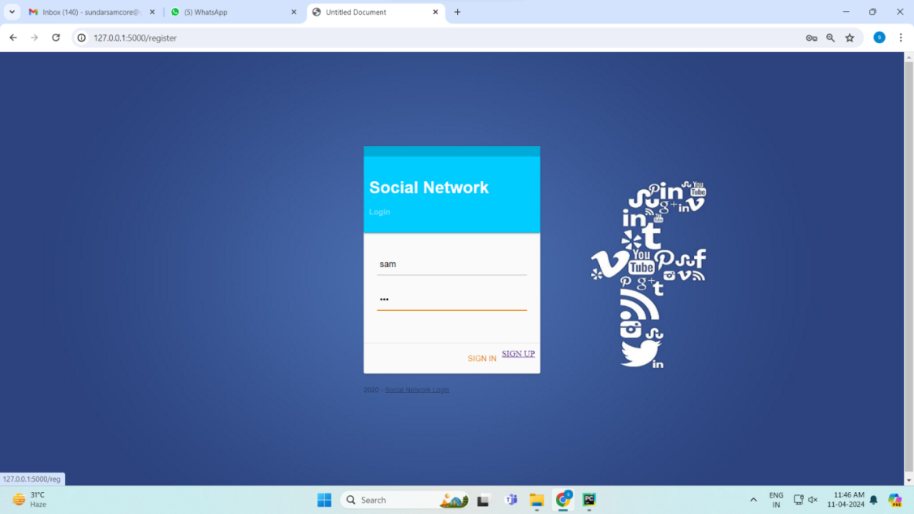

**Fig 7.1.1 social media login page**

As shown in fig.7.1.1 a user login form with username and password fields, and buttons to sign in or sign up, styled with a contemporary social media theme.

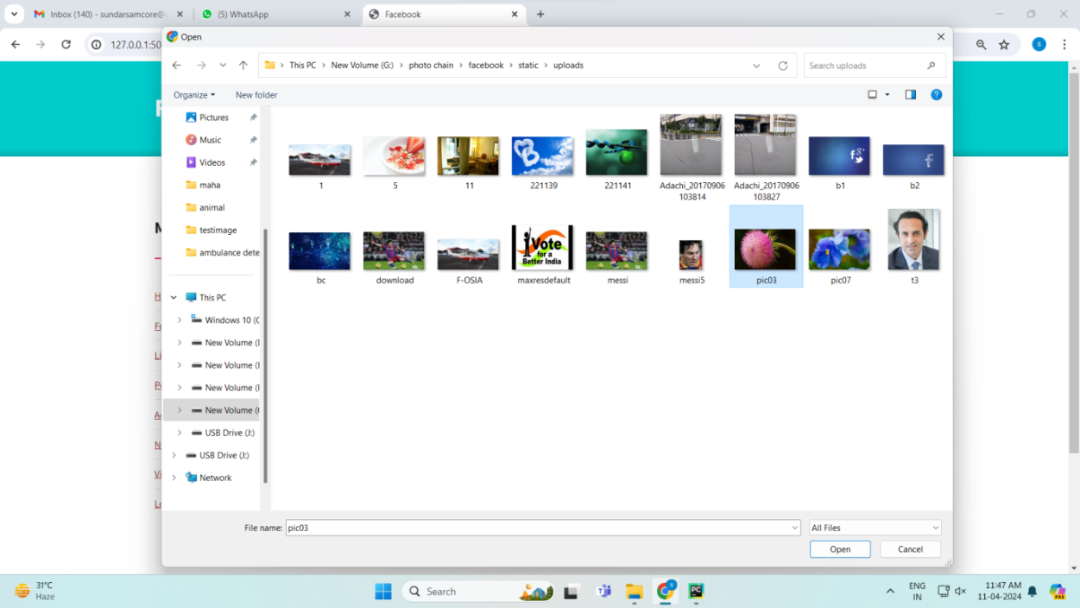

**Fig 7.1.2 choosing image**

As shown in fig.7.1.2 the file explorer window in which the user browses for an image from the local system to upload into the Social Network application.

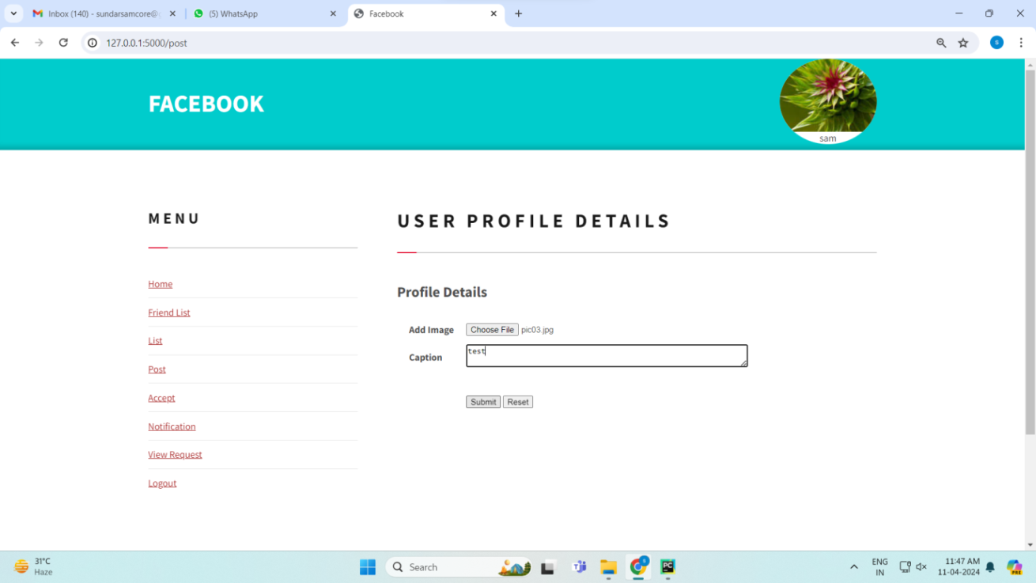

**Fig 7.1.3 user profile**

As shown in fig.7.1.3 of the user profile page where the user can upload a photo and include a caption for their post, with provisions for submitting or clearing the input.

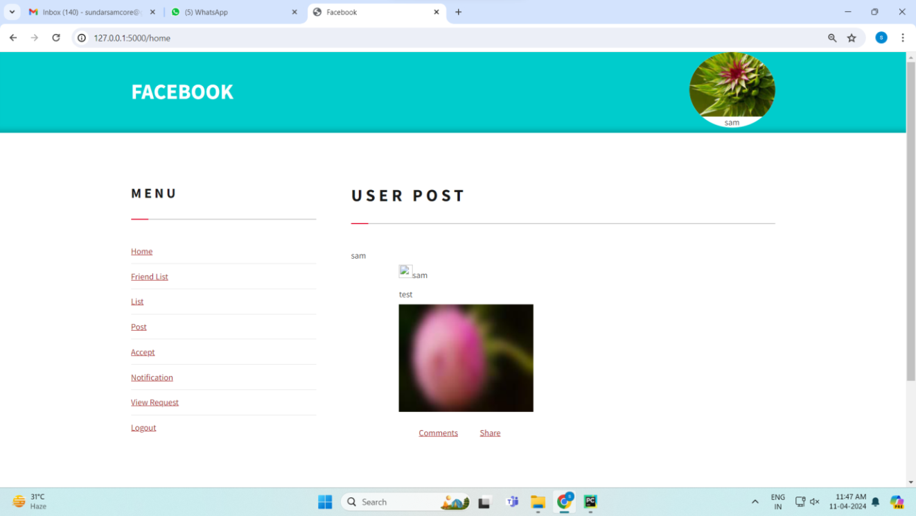

**Fig 7.1.4 post image**

As shown in fig.7.1.4 the home page on which the user's uploaded image, caption, and profile name are shown as a post along with comment options or the option to share the post.

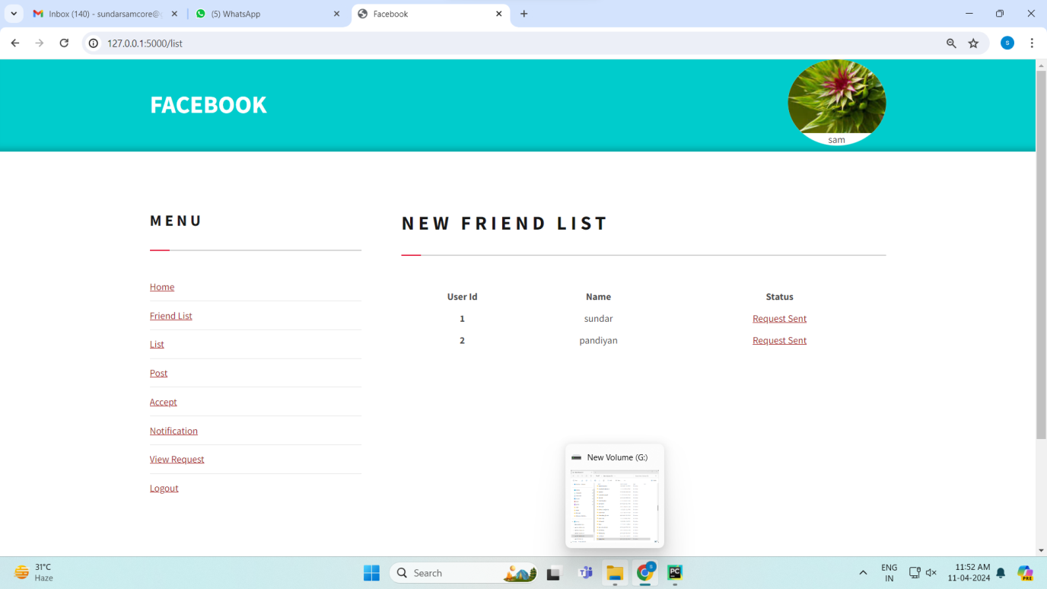

**Fig 7.1.5 New friend list**

As shown in fig.7.1.5 the list of users who were sent friend requests with their user IDs, names, and the status as "Request Sent" at the moment.

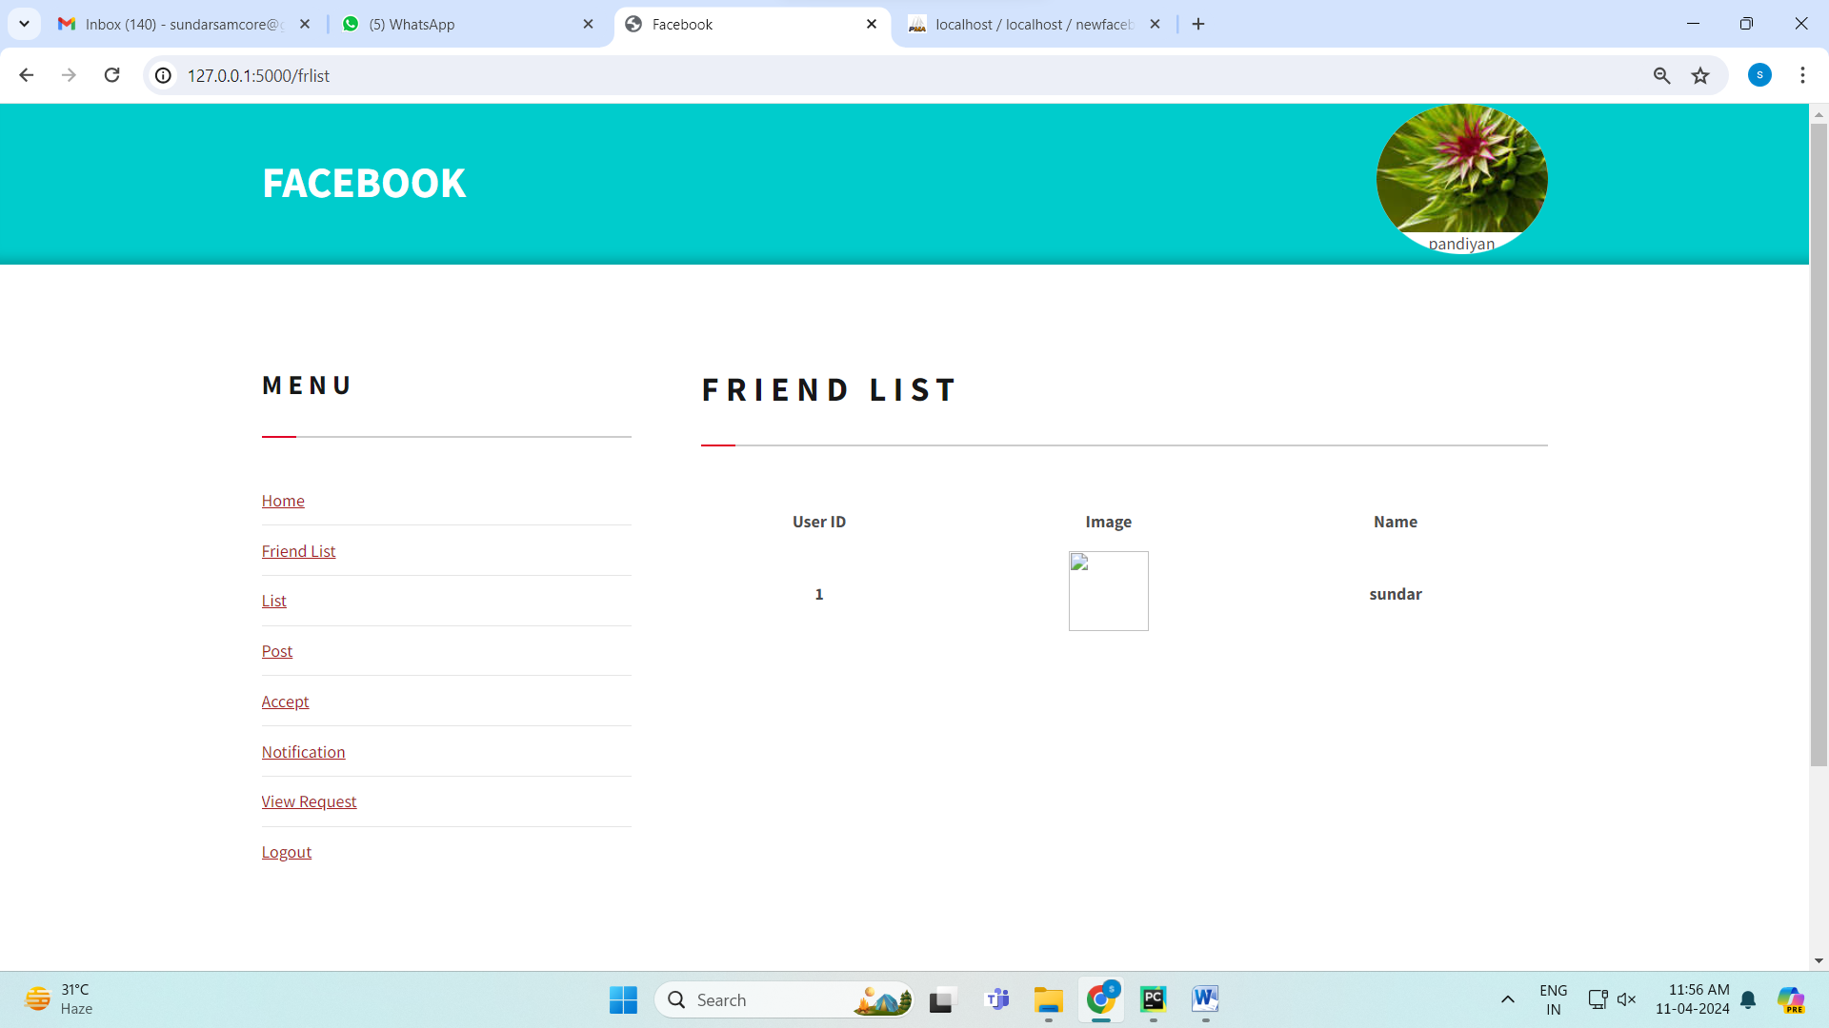

**Fig 7.1.6 friends list**

As shown in fig.7.1.6 represents the authenticated friend list of the currently logged in user, listing the friend's user ID, profile picture, and name.

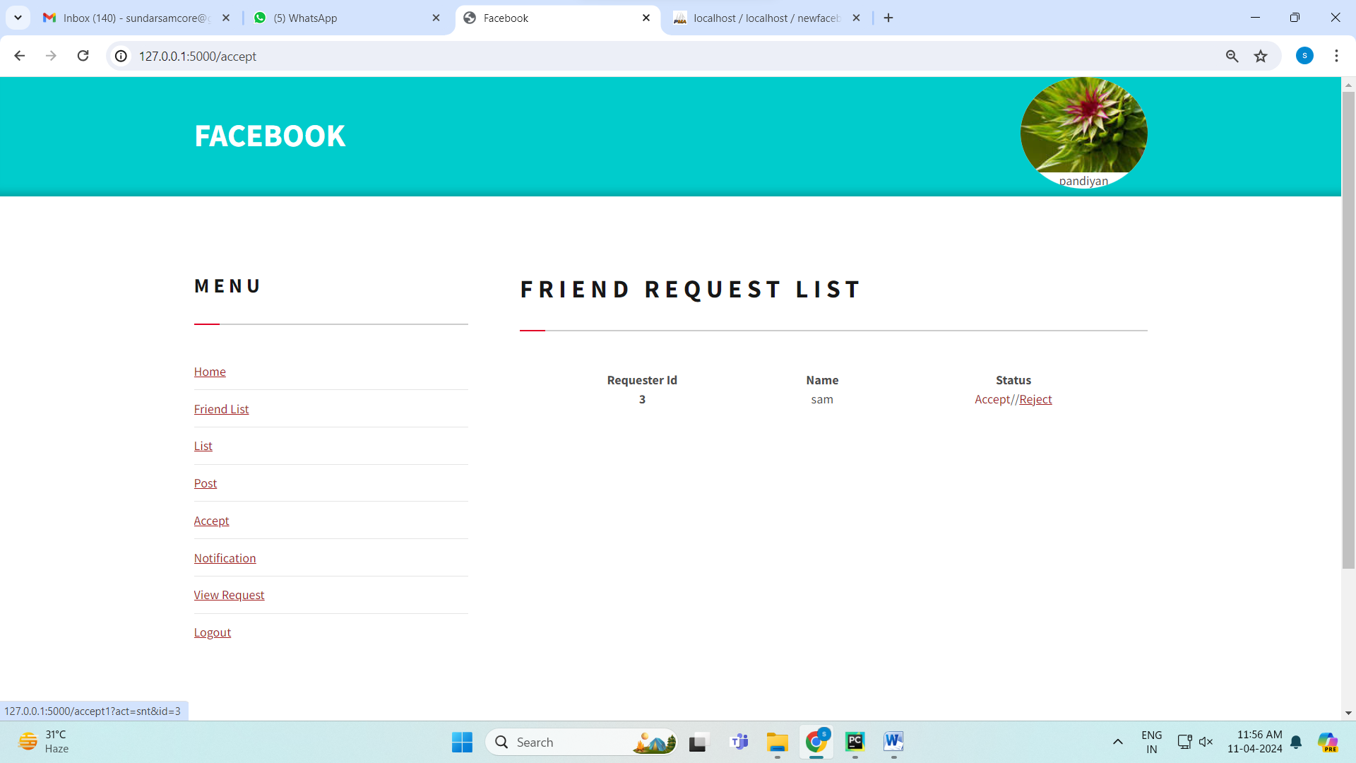

**Fig 7.1.7 Friend request list**

As shown in fig.7.1.7 indicates the pending friend requests sent to the user, listing the requester's ID and name and whether to accept or decline the request.

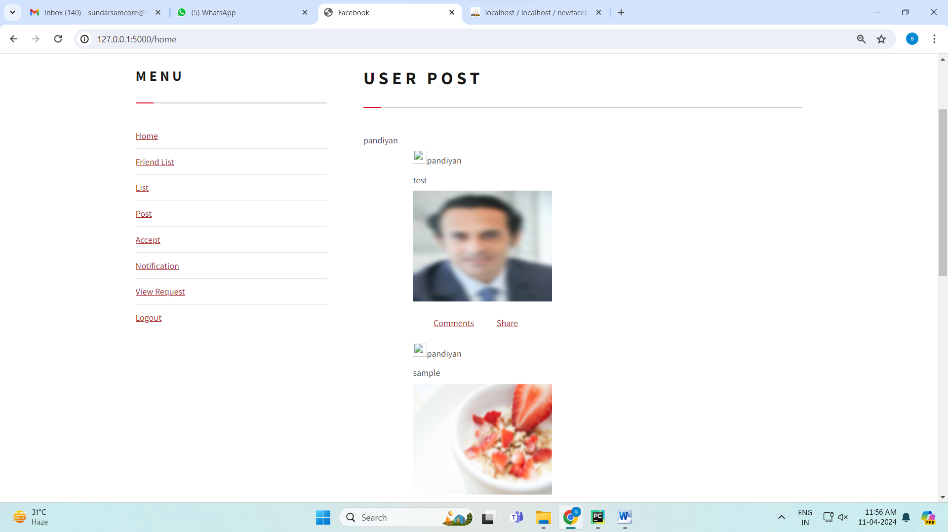

**Fig 7.1.8 posting images in blur mode**

As shown fig.7.1.8 allows users to upload images with a blur effect applied, either for privacy or stylistic purposes. Users can control the blur intensity before posting to share content selectively**.**

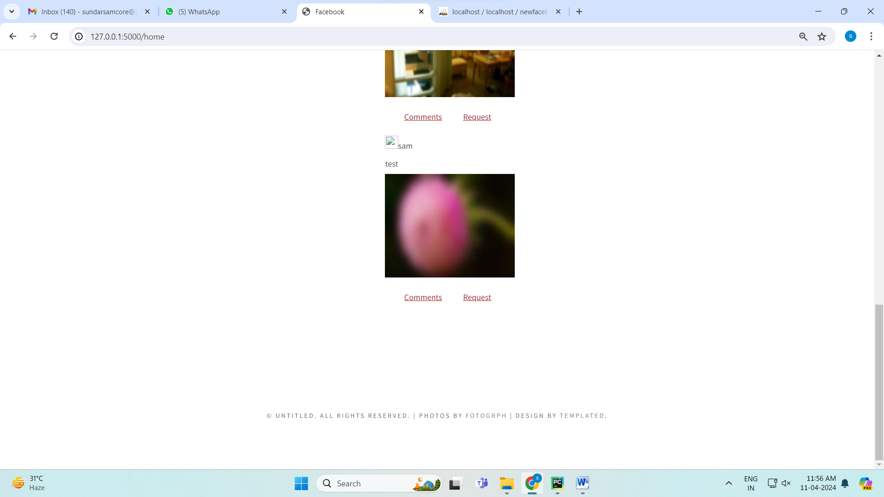

**Fig 7.1.9 posting images in blur mode**

As shown in fig.7.1.9 allowing users to block out information for privacy or aesthetic purposes. Users can preview and fine-tune the level of blur before publishing the photo.

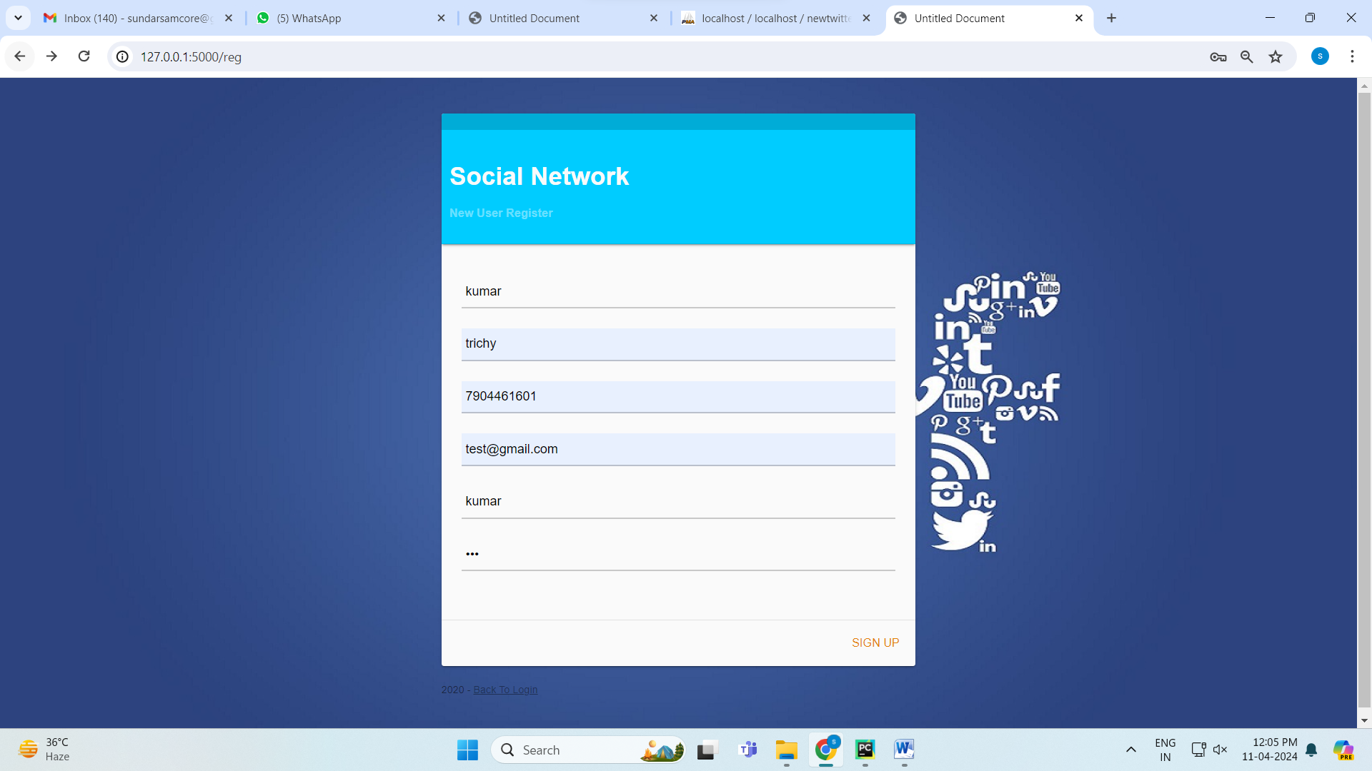

**Fig 7.1.10 social media register**

As shown in fig.7.10 interface enables fresh users to sign up and create an account by inputting vital information including username, email, and password. It supports user onboarding by obtaining registration details to access the social media site.

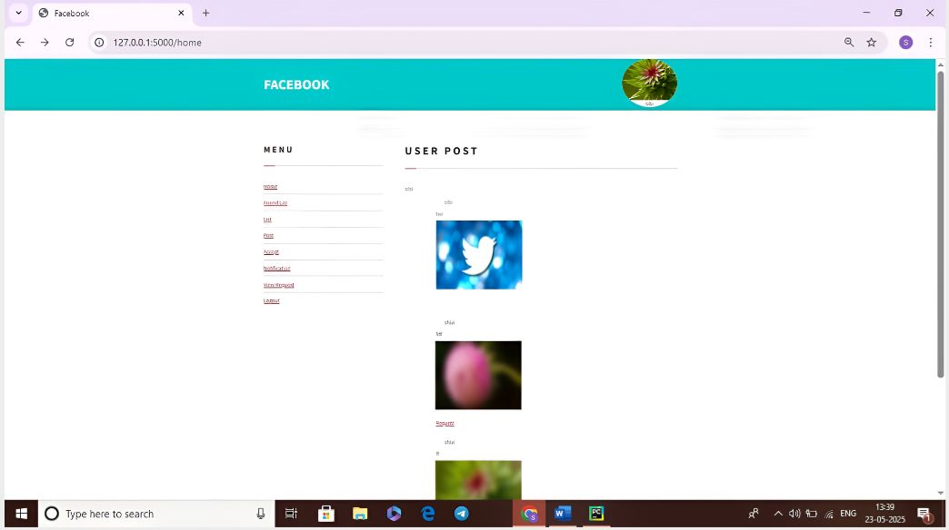

**Fig.7.1.11 Request photo**

As shown in Fig 7.1.11 the flow of request processing in the system architecture. It visually depicts how a user makes a request and how the system processes it stepwise.

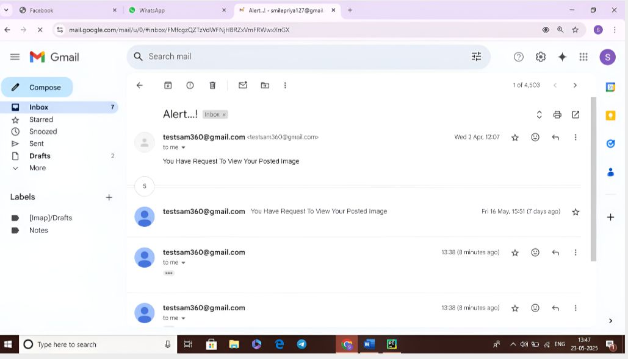

**Fig.7.1.12 Alert Notification**

As shown in fig.7.1.12 The notification system is programmed to alert the user's Gmail account in real time whenever certain actions or events happen within the system

**7.2 MODEL ACCURACY**

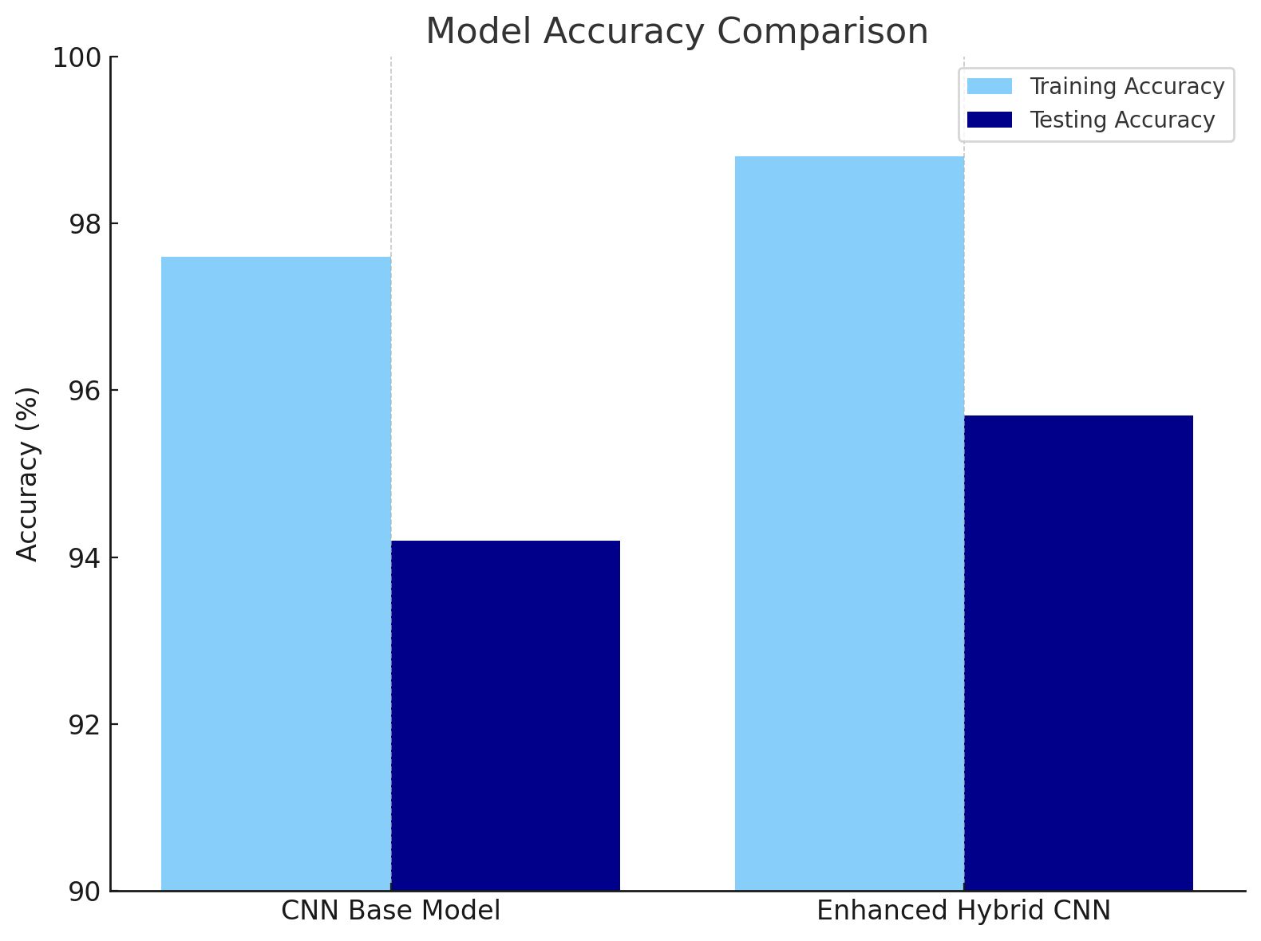

**Fig.7.2 Model Accuracy Comparison**

To Ensure strong and stable performance in photo sharing while maintaining privacy, our project employs a regular CNN Base Model as well as an Enhanced Hybrid CNN Model for image processing operations like face detection, verification of photos, and privacy violation detection. The CNN Base Model is popular for its effectiveness in extracting spatial features from images and has been chosen as a benchmark because it is simple and has established success in image classification tasks. To overcome its drawbacks especially when dealing with difficult situations with mixed images or metadata forgery we brought forth an Enhanced Hybrid CNN Model. This improved model combines deeper architectural components such as residual connections or multi-level fusion of features, which helps it learn shallow and deep visual patterns better. By testing the two models on benchmarks such as LT-EDI and Hugging Face, we confirmed that the hybrid model appreciably enhances accuracy and generalization. This verification not only shows the technical robustness of our solution but also increases the legitimacy of PhotoChain as a secure and smart photo sharing platform. Employing these two models guarantees that the system is able to learn in various image conditions, thus fulfilling the increasing requirement for user-oriented privacy control in social media scenarios.

**7.3 COMPARE WITH OTHER MODELS**

The existing systems lack robust privacy, control, and integrity features, often relying on centralized, insecure architectures.

**Table 7.3.1 Comparison with other models**

|  |  |  |
| --- | --- | --- |
| **Comparison** | **Existing System** | **Proposed System (PhotoChain)** |
| **Dissemination Control** | Limited or no control over how photos are shared across platforms, leading to unauthorized dissemination | Enables fine-grained dissemination control using blockchain, giving users power over photo access |
| **Privacy Protection** | Lacks advanced privacy features, increasing risk to personal identity in shared photos | Uses Gaussian Blur for automated face masking to anonymize individuals and enhance privacy |
| **Photo Integrity Verification** | Integrity verification is either absent or weak, making it easier to tamper with shared photos | Employs PreHash Algorithm and blockchain to ensure photo authenticity and detect tampering |
| **Access Control Mechanism** | Minimal or ineffective access control, often relying on platform-specific, inflexible settings | Implements strong, decentralized smart contract-based access control to manage permissions |
| **System Architecture** | Centralized platforms prone to data breaches and single points of failure | Fully decentralized Ethereum-based blockchain ensures transparency and security |
| **User Experience and Fairness** | Users face risks of misuse without assurance of fairness or transparency in data usage | Provides secure, fair, and transparent sharing, retrieval, and access of photos through smart contracts |

# 

# CHAPTER 8

**CONCLUSION AND FUTURE**

**ENHANCEMENT**

# CONCLUSION

# In this project, we designed, implemented and evaluated an extended control framework for blockchian enabled privacy-preserving photo sharing across different social networks, called PhotoChain.It helps social networking users to preserve their privacy requirements assigned on their uploaded photos, by control the operations of the following users on a dissemination chain. Meanwhile, it binds the access control polices to photos without disturbing the display phase. As a result, PhotChain could help social networking users to hide privacy areas away from unwanted viewers even in different social networks. Photochain not only protects the shared photos so that no unauthorized users can access them, but also enables users to blur their image search so that the search can also be shared to a cross social networking site obliviously without leakage on the query contents or results. The concept of PhotoChain which provides confidentiality, Integrity and privacy.In the future, we intend to explore the role of the latest technologies, such as federated learning, in preserving users’ privacy in CrossSNs.

# FUTURE ENHANCEMENT

The project involves addressing the increasing demand for privacy in photo sharing amid the widespread use of smart mobile devices and social networking applications. The project, known as PhotoChain, offers an extended control framework for blockchain-enabled privacy-preserving photo sharing across different social networks. This framework empowers users to preserve their privacy requirements for uploaded photos by controlling operations on a dissemination chain. Additionally, PhotoChain binds access control policies to photos without disrupting the display phase, enabling users to hide privacy areas from unwanted viewers across various social networks.

# APPENDICES

**APPENDIX -1 Coding**

from flask import Flask, render_template, flash, request,session  
from wtforms import Form, TextField, TextAreaField, validators, StringField, SubmitField  
from werkzeug import secure_filename  
import mysql.connector  
import urllib  
import urllib.request  
import urllib.parse  
import string  
import hashlib  
import base64  
import os  
from io import BytesIO  
import datetime  
import yagmail  
import tkinter.messagebox  
#import os, shutil  
app = Flask(__name__)  
app.config.from_object(__name__)  
app.config['SECRET_KEY'] = '7d441f27d441f27567d441f2b6176a'  
class ReusableForm(Form):  
 name = TextField('Name:', validators=[validators.required()])  
class Block:  
 blockNo = 0  
 data = None  
 next = None  
 hash = None  
 nonce = 0  
 previous_hash = 0x0  
 timestamp = datetime.datetime.now()  
 def __init__(self, data):  
 self.data = data  
 def hash(self):  
 h = hashlib.sha256()  
 h.update(  
 str(self.nonce).encode('utf-8') +  
 str(self.data).encode('utf-8') +  
 str(self.previous_hash).encode('utf-8') +  
 str(self.timestamp).encode('utf-8') +  
 str(self.blockNo).encode('utf-8')  
 )  
 return h.hexdigest()  
 def __str__(self):  
 return "Block Hash: " + str(self.hash()) + "\nBlockNo: " + str(self.blockNo) + "\nBlock Data: " + str(self.data) + "\nHashes: " + str(self.nonce) + "\n--------------"  
class Blockchain:  
 diff = 20  
 maxNonce = 2**32  
 target = 2 ** (256-diff)  
  
 block = Block("Genesis")  
 dummy = head = block  
 def add(self, block):  
 block.previous_hash = self.block.hash()  
 block.blockNo = self.block.blockNo + 1  
 self.block.next = block  
 self.block = self.block.next  
 def mine(self, block):  
 for n in range(self.maxNonce):  
 if int(block.hash(), 16) <= self.target:  
 self.add(block)  
 print(block)  
 break  
 else:  
 block.nonce += 1  
#blockchain = Blockchain()  
class ReusableForm(Form):  
 name = TextField('Name:', validators=[validators.required()])  
@app.route("/")  
def homepage():  
 return render_template('login.html')  
@app.route("/viewrq")  
def viewrq():  
 n = session['uname']  
 conn = mysql.connector.connect(user='root', password='', host='localhost', database='newfacebook')  
 cursor = conn.cursor()  
 cursor.execute("SELECT * from share1 where uname='" + n + "' and status='2'")  
 data = cursor.fetchall()  
 return render_template('viewrq.html',data=data)  
@app.route("/reg")  
def reg():  
 return render_template('register.html')  
@app.route("/profile")  
def profile():  
 return render_template('profile.html')  
@app.route("/register", methods = ['GET', 'POST'])  
def register():  
 error = None  
 if request.method == 'POST':  
 n = request.form['name']  
 # g = request.form['city']  
 # st = request.form['station']  
 email = request.form['email']  
 address = request.form['address']  
 pnumber = request.form['pnumber']  
 uname = request.form['uname']  
 password = request.form['password']  
 mydb = mysql.connector.connect(user='root', password='', host='localhost', database='newfacebook')  
 cursor = mydb.cursor()  
 mycursor = mydb.cursor()  
 mycursor.execute("select max(id) from register")  
 myresult = mycursor.fetchall()  
 for x in myresult:  
 y = x[0]  
 break  
 if y == None:  
 print("No such charater available in string")  
 x1=1  
 else:  
 y1 = y  
 x1 =int(y1)+1  
 cursor.execute(  
 "INSERT INTO register VALUES ('"+str(x1)+"','" + n + "','" + address + "','" + email + "','" + pnumber + "','" + uname + "','" + password + "','0','0','0','0')")  
 mycursor1 = mydb.cursor()  
 mycursor1.execute("select * from register where id!='"+str(x1)+"'")  
 myresult1 = mycursor1.fetchall()  
 for z in myresult1:  
 frid=z[0]  
 fname=z[1]  
 mycursor2 = mydb.cursor()  
 mycursor2.execute("insert into frlist(id,name,mailid,frid,frname,status)values('"+str(x1)+"','"+n+"','','"+str(frid)+"','"+str(fname)+"','0')")  
 mycursor2 = mydb.cursor()  
 mycursor2.execute("insert into frlist(id,name,mailid,frid,frname,status)values('" + str(frid) + "','" + str(fname) + "','','" + str(x1) + "','" + n + "','0')") #rt="http://bulksms.mysmsmantra.com:8080/WebSMS/SMSAPI.jsp?username=username&password=password&sendername=sender id&mobileno=919999999999&message=Hello"  
 mydb.commit()  
 mydb.close()  
 return render_template('login.html',data=myresult1,data1=myresult)  
@app.route("/login",methods = ['GET', 'POST'])

conn1 = mysql.connector.connect(user='root', password='', host='localhost', database='newfacebook')  
 cursor1 = conn1.cursor()  
 cursor1.execute(  
 "SELECT upost.id,comment.id,comment.uname,comment.cmt FROM upost INNER JOIN comment ON upost.id = comment.mid WHERE upost.sid = '" + str(  
 uid) + "' and comment.status='1'")  
 data = cursor1.fetchall()  
 conn11 = mysql.connector.connect(user='root', password='', host='localhost', database='newfacebook')  
 cursor11 = conn11.cursor()  
 cursor11.execute(  
 "SELECT upost.id,upost.image,upost.cption FROM upost INNER JOIN share ON upost.id = share.mid WHERE upost.sid = '" + str(  
 uid) + "' and share.status='1'")  
 data1 = cursor11.fetchall()  
 print('data')

**APPENDIX – 2**

**PUBLICATIONS IN CONFERENCES**

Presented a paper entitled “AN EFFICIENT BLOCKCHAIN BASED FRAMEWORK FOR FILE SHARING” in International Conference on Innovative Research in Engineering and technology (ICIRET- 2025) organized by Department of Information Technology, A.V.C. College of Engineering, Mannampandal, Mayiladuthurai on 28.03.2025.

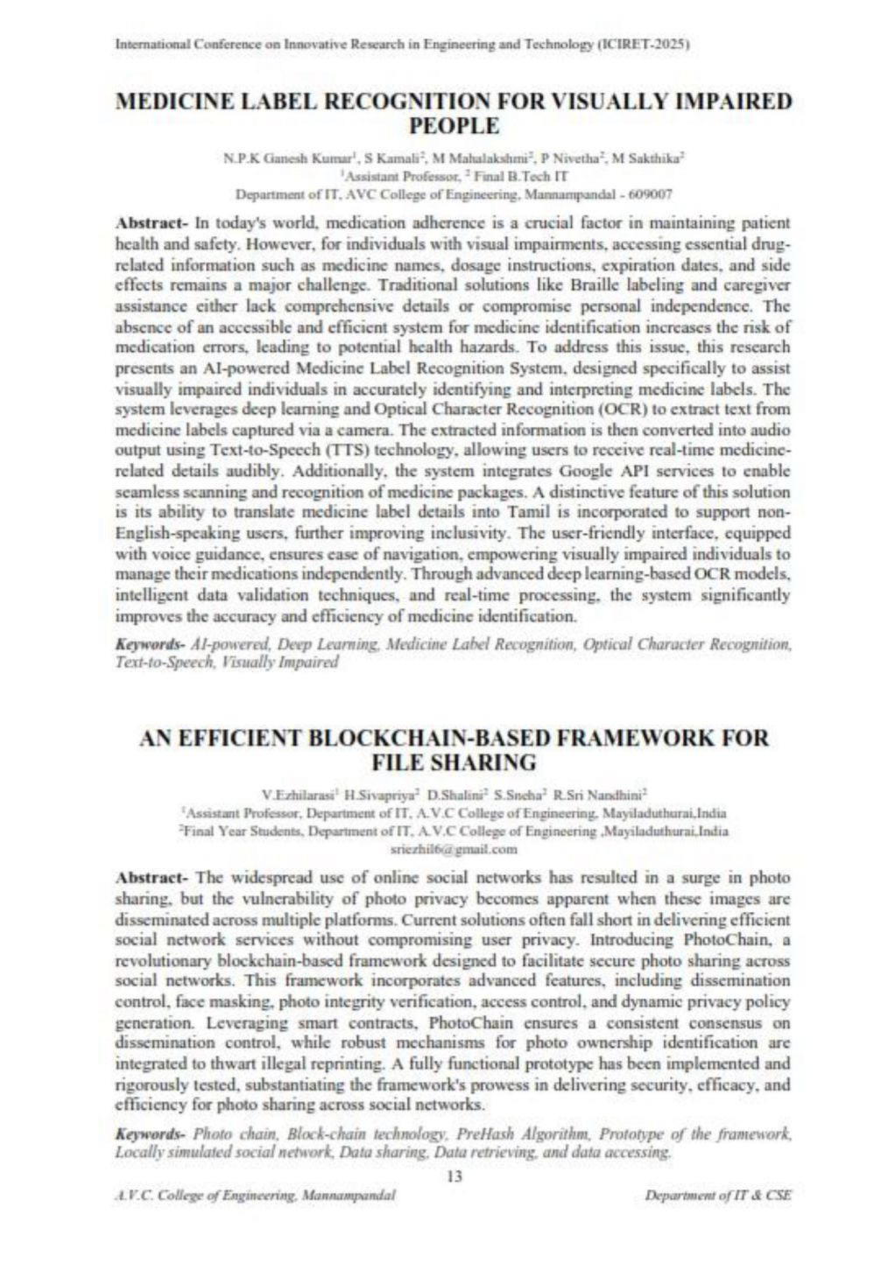









**REFERENCES**

[1.] Bhatt, H. S., Bharadwaj, S., Singh, R., & Vatsa, M. (2013). Recognizing surgically altered face images using multi-objective evolutionary algorithm. *IEEE Transactions on Information Forensics and Security, 8*(1), 89–100.

[2.] Bonneau, J., Anderson, J., & Church, L. (2009). Privacy suites: Shared privacy for social networks. In *Proceedings of the Symposium on Usable Privacy and Security*.

[3.] Bort, J. (2019). A high school coach was fired for this Facebook photo. Accessed: June 8, 2019.

[4.] CareerBuilder. (2019). Number of employers using social media to screen candidates has increased 500 percent over the last decade. Accessed: June 8, 2019.

[5.] Carminati, B., Ferrari, E., Heatherly, R., Kantarcioglu, M., & Thuraisingham, B. (2011). Semantic web-based social network access control, pp. 108–115.

[6.] Dent, J. (2019). Revenge porn: Image-based hits ‘one in five’ Australians. Accessed: June 8, 2019.

[7.] Ding, C., Xu, C., & Tao, D. (2015). Multi-task pose-invariant face recognition. *IEEE Transactions on Image Processing, 24*(3), 980–993.

[8.] Had, S., Benouar, M., Kedir-Talha, M., Abtahi, F., Attari, M., & Seoane, F. (2018). Full impedance cardiography measurement device using Raspberry PI3 and system-on-chip biomedical instrumentation solutions. *IEEE Journal of Biomedical and Health Informatics, 22*(6), 1883–1894.

[9.] Kapadia, A., Adu-Oppong, F., Gardiner, C. K., & Tsang, P. P. (2008). Social circles: Tackling privacy in social networks. In *Proceedings of the Symposium on Usable Privacy and Security*.

[10.] Kaszubska, G. (2019). Not just ‘revenge porn’—Image-based abuse hits 1 in 5 Australians. Accessed: June 8, 2019.

[11.] Kowshika, A. (2019). Least mobility high power (LMHP) dynamic routing for QoS development in MANET. *Wireless Personal Communications*, Springer US, March 2019.

[12.] Lekhaa, T. R. (2016). Secured credit card transaction using webcam. *International Research Journal of Engineering and Technology*, April 2016.

[13.] Li, S., Shan, S., & Gao, W. (2012). Coupled bias-variance tradeoff for cross-pose face recognition. *IEEE Transactions on Image Processing, 21*(1), 305–315.

[14.] Liang, J., Zhao, H., Li, X., & Zhao, H. (2017). Face recognition system based on deep residual network. In *Proceedings of the 3rd Workshop on Advanced Research and Technology in Industry Applications (WARTIA)*, pp. 5–10.

[15.] Pan, X. (2012). Research and implementation of access control system based on RFID and FNN-face recognition. In *Proceedings of the 2nd International Conference on Intelligent System Design and Engineering Applications*, pp. 716–719.

[16.] Squicciarini, A. C., Sundareswaran, S., Lin, D., & Wede, J. (2011). A3P: Adaptive policy prediction for shared images over popular content sharing sites. In *Proceedings of the 22nd ACM Conference on Hypertext and Hypermedia*, pp. 261–270.

[17.] Taleb, M., Ouis, E. A., & Mammar, M. O. (2014). Access control using automated face recognition: Based on the PCA & LDA algorithms. In *Proceedings of the 4th International Symposium ISKO-Maghreb, Concepts Tools and Knowledge Management (ISKO-Maghreb)*, pp. 1–5.

[18.] Wazwaz, A. O., Herbawi, M. J., Teeti, O., & Hmeed, S. Y. (2018). Raspberry Pi and computers-based face detection and recognition system. In *Proceedings of the 4th International Conference on Computer Technology and Applications (ICCTA)*, pp. 171–174.

[19.] Yang, J., Lei, Z., Yi, D., & Li, S. (2015). Person-specific face antispoofing with subject domain adaptation. *IEEE Transactions on Information Forensics and Security, 10*(4), 797–809.

[20.] Yeung, C. A., Kagal, L., Gibbins, N., & Shadbolt, N. (2009). Providing access control to online photo albums based on tags and linked data, pp. 9–14.